INDIVIDUAL PROGRESS REPORT BY SIMRANPREET KAUR

As a group, we divided our project into three parts as each member contribute equally to the project. My team wants me to handle Risk assessment and also a plan to address those risks. I even worked to collect the list of technical hardware and software components that I need to use to implement the proposed solution.

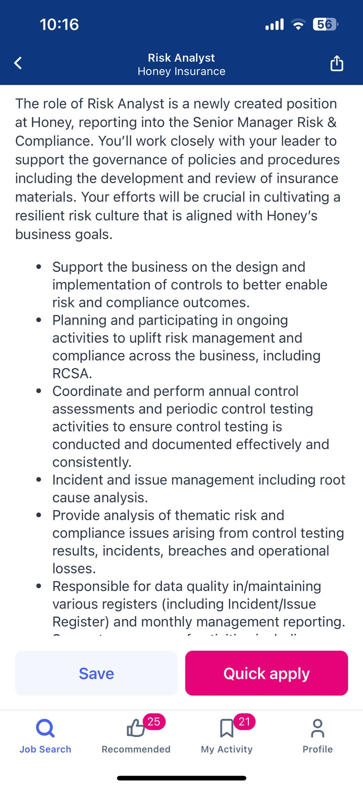Based on the given responsibilities, I appreciate the opportunity to serve as a Risk Analyst in such a crucial project. The responsibilities that come with this role are indeed significant, and I am thrilled to share them with you. It is an honour to contribute my skills and expertise towards ensuring the success and safety of this project. To learn much more about the responsibilities of Risk Analyst, I go through [www.seek.com.au](http://www.seek.com.au) and serve for some company who offers this post. Here is one of the example:

This company posted a vacancy of Risk analyst and here are their major key responsibilities:

Risk Assessment

As a risk analyst, my primary job is to assess potential risks and threat that could impact an organisation. This includes evaluating both external and internal factors that could affect the organization’s objectives, such as financial market conditions, regulatory changes and operational vulnerabilities.

Data Analysis

Gathering and analysing data from various sources to qualify and evaluate risks. This may involve using statistical methods, risk management software to assess the potential impact of different risk scenarios with precision. After assessing risks, I work with the team to develop mitigation strategies to minimize the impact or likelihood of occurrence.

Compliance and regulatory oversight

This is my responsibility to stay informed about relevant laws, regulations, and industry standards related to risk management of the project. To prevent legal and regulatory problems, I ensure that my firm complies with all regulations.

Communication and reporting

One of the major aspects of the project is a communication, as better communication always succeeds for better results. As a Risk analyst, my responsibility is to gather complicated risk information in a simple and accessible manner to stakeholder and decision makers so they can plan accordingly. For example, writes studies for other team members that outline the prospective impact of regulatory changes on their operations.

Study Market Trends

For giving our best results it is essential that I will make myself updated with the current trends in the business market and comes up with a suitable strategy. With this, I am able to give up-to date results to compile with organisation demands.

Developing Risk management tools

After assessing risk, with the help of other project members I will develop and implement risk management tools and systems such as risk registers and incident reporting processes to reduce the impact of any risk on our project. So, we can have a success at the end of the project.

Being a member of a project, it can be tough when it comes to working together at the same time. We all try to collaborate and strive for a successful project as per the needs. As this role require a strong analytical skill, attention to detail and ability to communicate effectively with stakeholders across the project. By collaborating closely with my team members and leveraging each other’s expertise, I can ensure that the project is well-equipped to address potential risks and security threats.

References:

Insurance, H. (2024). *Risk Analyst Job in Sydney NSW*. [online] SEEK. Available at: <https://www.seek.com.au/job/74472112>

[Accessed 24 Mar. 2024].